Big Mountain Project Report
Table of Contents

Contents
Problem Identification 1
Solution Approach 2
Performing Data Wrangling 2
Performing Exploratory Data Analysis 5
Implementing further Data science Techniques 7
Pre-Processing and Training Data Development 7
Initial Models 7
Scale Standardization 8
Pipelines 9
Developing Modelling 9
Model framework used 11
Conclusion 15

Problem Identification

Big Mountain ski resort located in Montana is seeking guidance on how to select a better value for their ticket price , current ticket price during weekend for Adults is $81.00, they were open to considering changes that will either cut costs without undermining the ticket price considering they invested in their resort an additional chair lift which resulted in $1,540,000 operational costs. Using the SMART (S – Specific, M – Measurable, A – Achievable, R – Realistic, T – Timebound) Principals Identified various critical elements that were necessary for arriving at the solution, mainly identified Criteria for success as:
1. Optimal ticket pricing that is based on data driven analysis and that reflects true value of facilities and services.
2. Business is able to gain clear insights into which facilities/services that drive the most value so that this analysis guides future investment decisions
And Scope of solution as :
1. Pricing strategy and revenue optimization
2. Facility utilization and value assessment
3. The new chair lift added $1.54 million in operating costs, highlighting a need for efficiency.
4. Investment and Strategic Decision Support
Overall implementing a data driven strategy to provide recommendations to the case.

Solution Approach

Performing Data Wrangling
Reviewed Raw data available to better understand the Data shape & Data quality. Leveraged various Python and Pandas functions to identify missing values, duplicate values to create a effective data that can be further used to assess numeric and categorical features. Using matplotlibs’s subplot understood the distribution of resorts by Region and State:

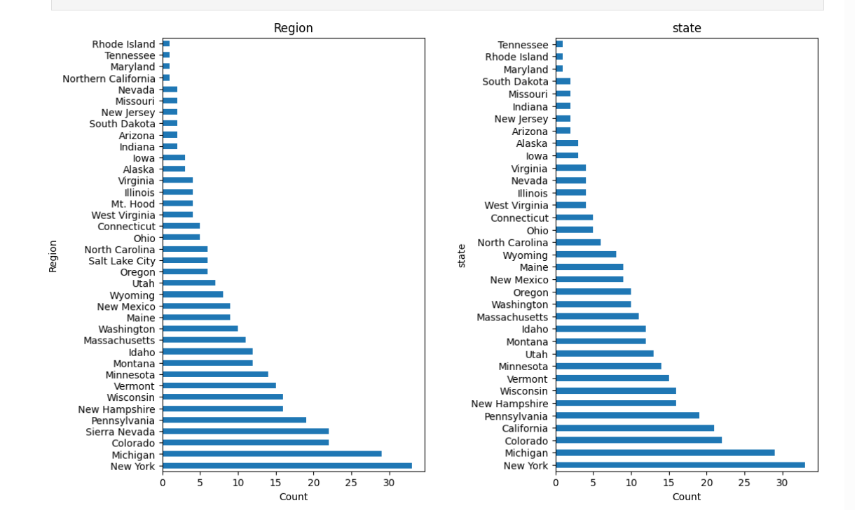

Since our primary focus is our Big Mountain resort, in Montana. This gives clues to help decide what our primary target response feature should be (weekend or weekday ticket prices)? Going thru the progressive elaboration steps found that seaborn's boxplot function to create boxplots of the ticket price distributions for each ticket type for each state is very effective visual representation of data we are interested in further exploring.
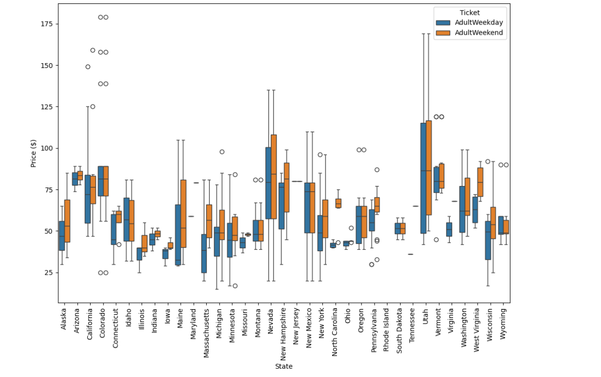
Drilled down further to understand the distribution of feature that are of interest to the use case and create data frame of summary statistics for various states. Identified Target feature when modelling ticket price to prepare for understanding the relationship between weekday and weekend prices.

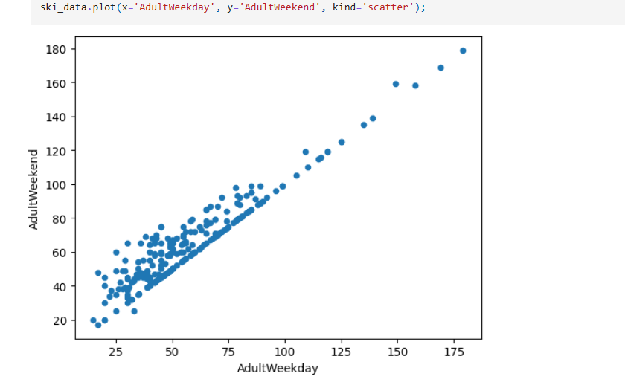
To conclude the steps at high level, removed rows where both weekday and weekend prices were missing, dropped unnecessary columns that were not helpful in the use case, standardized state names, most importantly handled outliers by filtering extreme values in numeric columns.
Performing Exploratory Data Analysis (EDA)
Based on the initial Data Wrangling results, implemented EDA approach to summarize and visualize important characteristics and statistical properties of a dataset. The key highlights of this steps provided valuable information and potentially useful features
- First, summit and base elevation for all the resorts in the data found to be quite highly correlated.
- Resorts are more densely located with population, more night skiing is provided
- Attribute - AdultWeekend ticket price had significant reasonable correlations with Attributes - fastQuads, along with Runs and Snow Making.
- Visitors would seem to value more guaranteed snow, which would cost in terms of snow making equipment, which would drive prices and costs up.
- Attribute- resort_night_skiing_state_ratio seems the most correlated with ticket price.
- Attributes Runs, total_chairs is quite well correlated with ticket price.
- Attribute vertical drop seems to be a selling point that raises ticket prices as well.

These were derived after disentangling web of relations via PCA (Principle Components Analysis), which helped us find linear combinations of the original features that are uncorrelated with one another and order them by the amount of variance. The basic steps in this process were:
- scale the data (important because our features are heterogenous)
- fit the PCA transformation (learn the transformation from the data)
- apply the transformation to the data to create the derived features
- used the derived features to look for patterns in the data and explore the coefficients

Used the matplotlib scatter plot scaled data to assess Ski states summary PCS with information about average price.

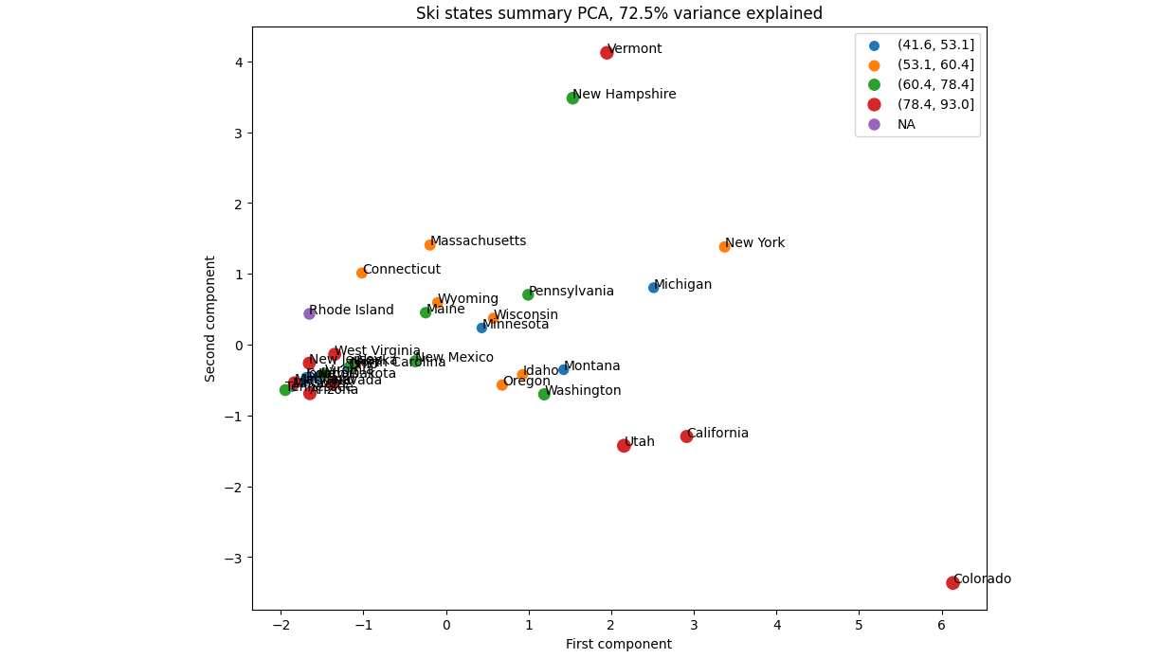

Overall, the EDA guided us into selecting primarily numeric features (with careful handling of correlated ones), helped us accomplish engineer intuitive features to proceed with feature engineer. This steps helped us identify AdultWeekend as the target feature, and treating state labels either lightly or through aggregated engineered attributes. And Correlations viewed through heatmap helped us identify patterns and helped us dive into how ticket price varies with other numeric features of interest listed in above.

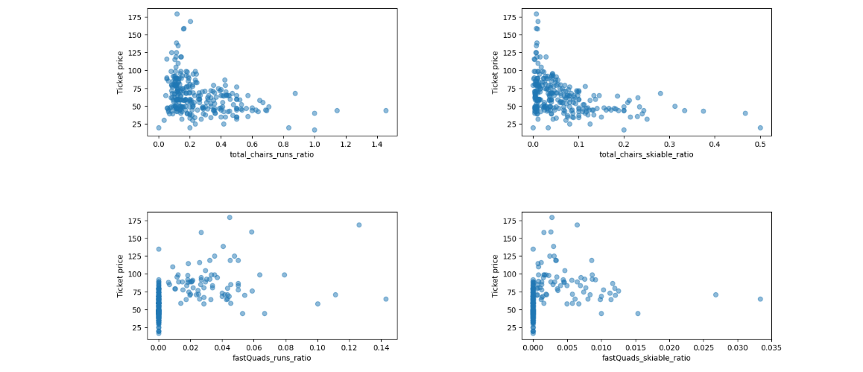

Implementing further Data science Techniques
Pre-Processing and Training Data Development
As a precursor to building model, created a 70/30 train/test split to ensure there is an opportunity to conduct cross validation and 30% of data is not introduced to machine learning model. Also dropped the target feature (‘AdultWeeked’ price) from the data to prevent data leakage. Because if the target column stays in Training data set the model could “cheat” by learning directly from the answer, which leads to unrealistically high performance during training and poor performance on real data.
Used sklearns DummyRegressor to produce same results as R-squared value of the input and arrived as the same results. Computing MSE resulted arriving at the understanding that on average, we might expect to be off by around $19 if we guessed ticket price based on an average of known values.
Initial Models
By imputing missing values from a train split and applying that to the test split to assess how imputation worked.
- Imputed missing values in test set with median and applied that to both train and test splits.
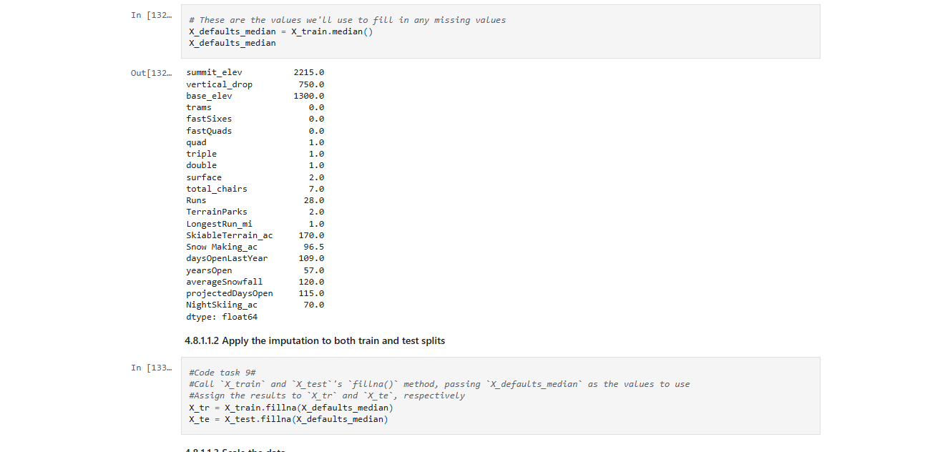

Scale Standardization
Using StandardScaler() scaled feature to zero mean and unit variance
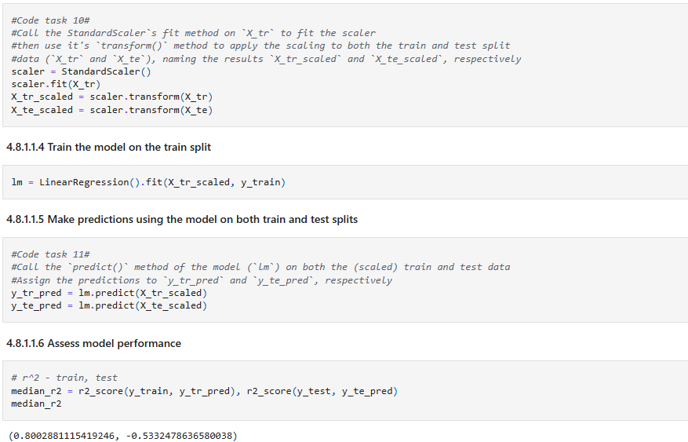
Here we see that our simple linear regression model explains over 80% of the variance on the train set and over 70% on the test set.

Pipelines
Using sklearn’s pipeline component, simplified individual functions and tasks performed to arrive at initial linear model. Assessed the performance resulting out of pipeline functions and repeated the process to create a redefined pipeline. Assessed for model overfitting as well and addressed appropriate feature selection using SelectKBest function.
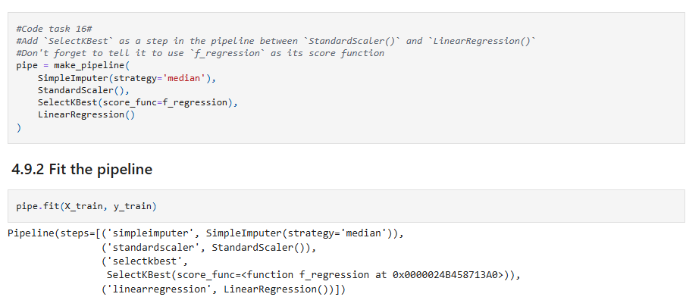

Developing Modelling
Random Forest model is known to work in lot of cases and sklearn's RandomForestRegressor helps us assessing performance using cross validate.

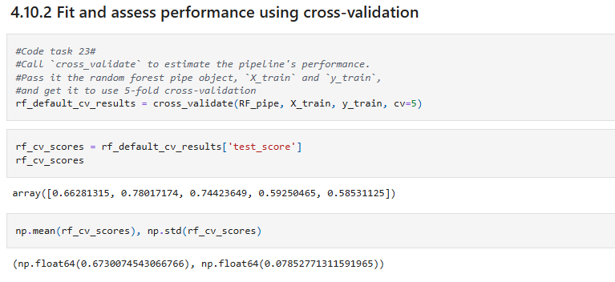

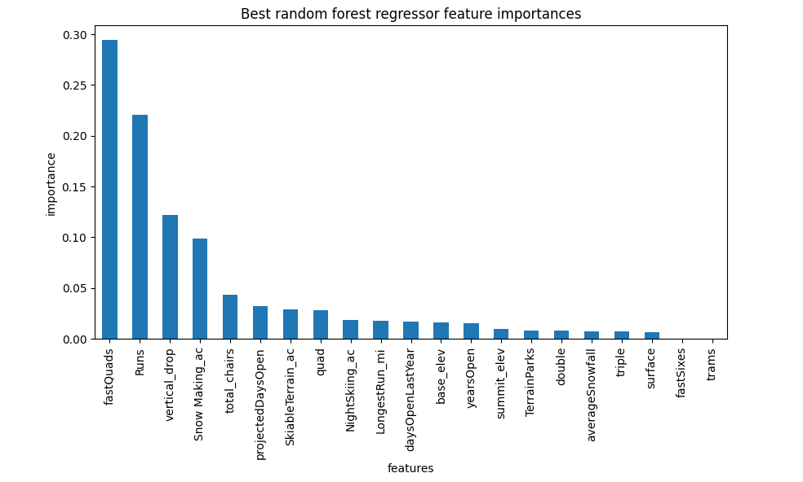

Further regression on Random forest model performance helped us conclude that performance on the test set produces performance consistent with the cross-validation results.

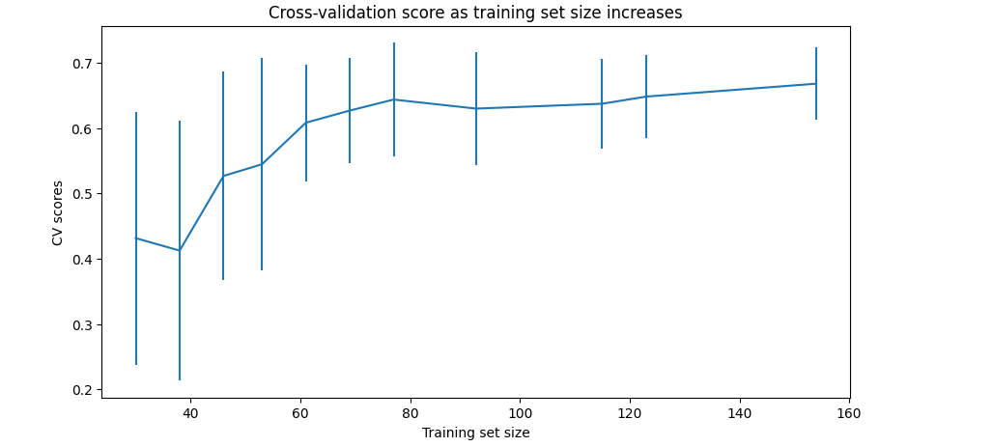

This showed that we seem to have plenty of data. There's an initial rapid improvement in model scores as one would expect, but it's essentially levelled off by around a sample size of 40-50.

Model framework used

We loaded the Random forest model generated in earlier step by excluding the Big Mountain data to refit the model and eliminate bias. Calculated expected Big Mountain Ticket price from the model and concluded that : Big Mountain Resort modelled price is $108.30, actual price is $81.00. Even with the expected mean absolute error of $10.24, this suggests there is room for an increase.
Used matplotlib’s histogram plots with values of feature to see where Big Mountain sits overall amongst all resort prices. Some of the features assessed are listed below:

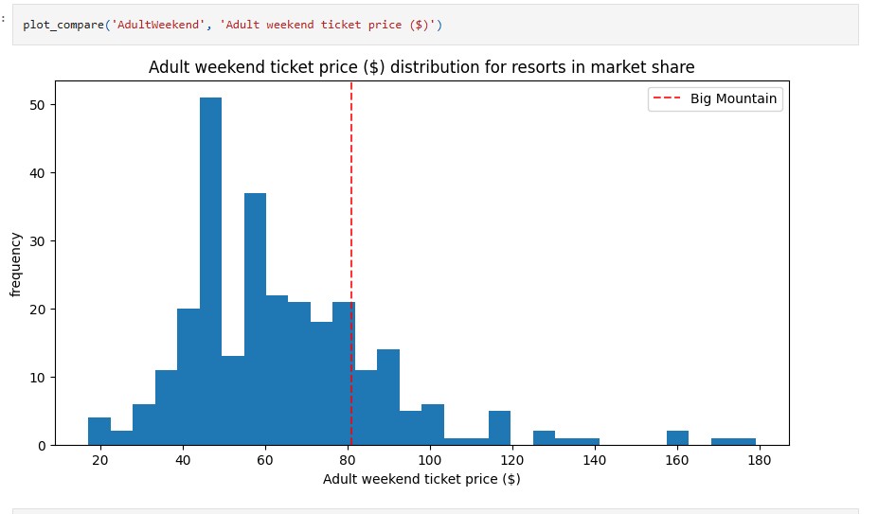

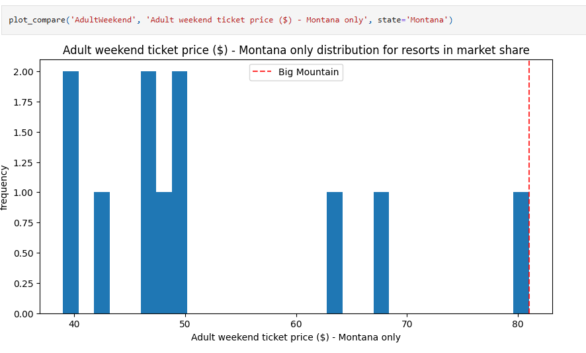

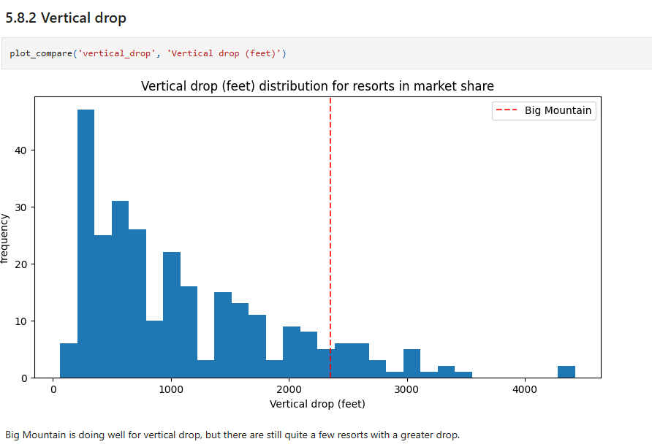

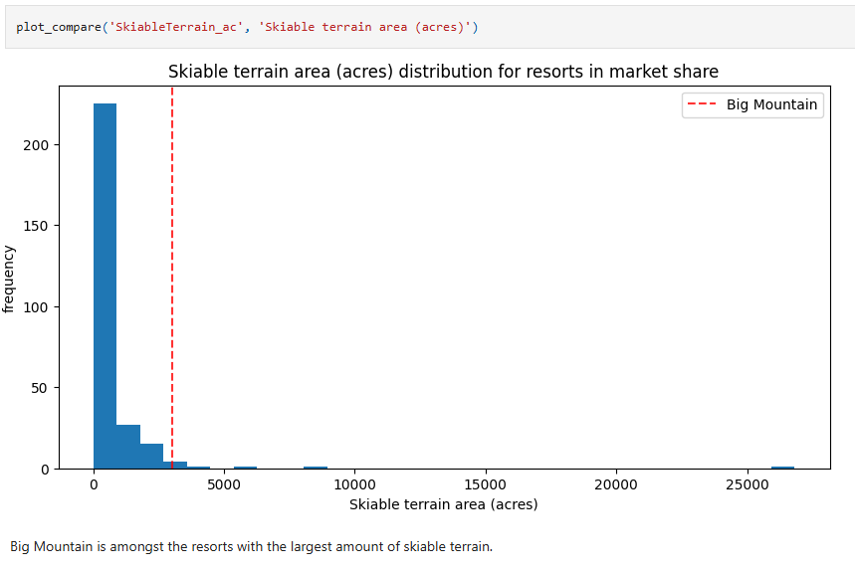

Finally, some of the scenarios were shortlisted to model based on this options:
- Permanently closing down up to 10 of the least used runs.
- Increase the vertical drop by adding a run to a point 150 feet lower down but requiring the installation of an additional chair lift to bring skiers back up, without additional snow making coverage
- Same as number 2, but adding 2 acres of snow making cover
- Increase the longest run by 0.2 mile to boast 3.5 miles length, requiring an additional snow making coverage of 4 acres
The expected number of visitors over the season is 350,000 and, on average, visitors ski for five days. Assume the provided data includes the additional lift that Big Mountain recently installed.
Of the 5 scenarios run, model supported that : if Big Mountain is adding a run, increasing the vertical drop by 150 feet, and installing an additional chair lift it will support the increase in the ticket price by $3.00 and over the season, this could be expected to amount to $5250000.

Conclusion
Therefore, we can conclude that Big Mountain should consider adding a run, increase the vertical drop by 150 feet, and install an additional chair lift to bring in more revenue. This will justify $3.00 increase in current ticket price $81.00 per adult.

